Bookstore Website Development

Software Requirements Specification
Version 4 .0

Danang, Mar 2025

TABLE OF CONTENTS
TABLE OF CONTENTS 2
1. DOCUMENT HISTORY 4
2. REFERENCE DOCUMENTS 4
3. DISTRIBUTION LIST AND APPROVALS 5
4. INTRODUCTION 5
4.1 Purpose 5
4.2 In Scope 5
5. OVERVIEW 6
5.1 Actors 6
5.2 System Use Case Diagram 7
6. Functional Description 8

DOCUMENT HISTORY
Date | Summary of Changes | Version
16/01/2025 | Software Requirements Specification | 1.0
20/01/2025 | New document creation | 1.0

REFERENCE DOCUMENTS
Document Name | Description
Bookstore Website Solution Specification | Reviewed for functional specification details
http://fahasa.com | Example of an online bookstore
http://tiki.com | Example of an online bookstore

DISTRIBUTION LIST AND APPROVALS
This document is distributed to the following stakeholders to get their valuable comments and corrections.
Name | Title
- Phan Minh Vinh | Task allocation among team members.  Define website design directions, provide documentation, and Requirement Outline.  Specify use cases for the member module.  Complete sections 6.11–6.15.
- Nguyễn Văn Toàn | Research documentation, design basic screens.  Specify use cases for the customer module.
- Phạm Võ Thế Anh | Research documentation.  Support team members in data selection and screen layout.
4. Nguyễn Quang Vinh | Research documentation.  Specify use cases for the administrator module.  Design error-handling mechanisms
5. Ngô Văn Thuận | Specify use cases for the administrator module.  Expand use-case descriptions.  Design administrative interface screens.

INTRODUCTION

Purpose
Buying and selling books is an essential need for everyone, especially for those who love reading or seek study and research materials. Access to books and documents plays a crucial role in personal knowledge development and serves various learning and research purposes.
This online bookstore website is designed to facilitate book transactions between the admin and users. The goal of the system is to provide a simple, convenient, and user-friendly platform that allows users to quickly find and acquire their favorite or necessary books for work and study.
The system enables admins to manage books, adjust prices, and control stock levels. Book details, categories, and prices are clearly and comprehensively presented to users, making it easier for them to search and make quick and informed purchase decisions.
With features such as searching for books by title, author, category, and price, users can easily select and purchase suitable books. At the same time, admins can efficiently manage book inventories, update book information, and process orders effectively.
This bookstore website not only helps users buy books but also creates a safe, convenient, and transparent online shopping environment between users and admins.

In Scope

The bookstore website will serve nationwide book transactions, enabling users to buy and sell books conveniently across all regions. Users can select their province or city and access website functions based on their assigned module.

Geographical Scope: The website supports users nationwide, allowing book purchases and sales from any location.

User Functions: Buyers can search for books, make online payments, and receive books via shipping.

Admin Functions: Administrators manage books, update information and pricing, and process orders.

User Accounts: Users can register an account, manage their orders, and review purchased books.

Out of Scope: The project does not include book exchanges, book rentals, or external shipping services.

OVERVIEW

Actors
The diagram below describes the actions of users in the system. The system consists of three modules, each with its own set of actions based on access rights and privileges.
Người dùng | Mô tả
Administrator (Admin) | Administrators are responsible for managing the website, monitoring users, and overseeing system activities. They have exclusive access to the admin panel and can use various management tools.  Functions:  - Add, edit, delete, and view book lists.  - View book categories and products.  - Export reports to Excel.  - Search and filter available books.  - Add/Edit/Delete advertisement banners.  - Configure mail server settings.
Guest (No account required) | Functions:  - View book lists (main/subcategories).  - Search for books:  - + By category  - + By type  - + By keywords  - Register a regular user account.  - View contact details of other users.  - List books (by price/author).  - View book details.  - Send inquiries to administrators via email.
Registered User | Users who have registered and activated their accounts on the website.  Functions (in addition to Guest functions):  - Log in.  - Log out.  - Change or reset password.  - View and edit personal information.  - Place book orders.  - View purchase history.  - Provide feedback.

System Use Case Diagram
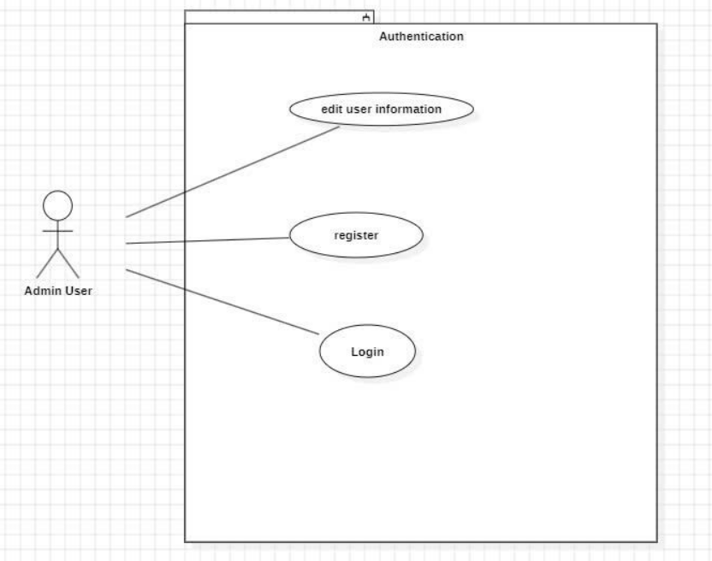

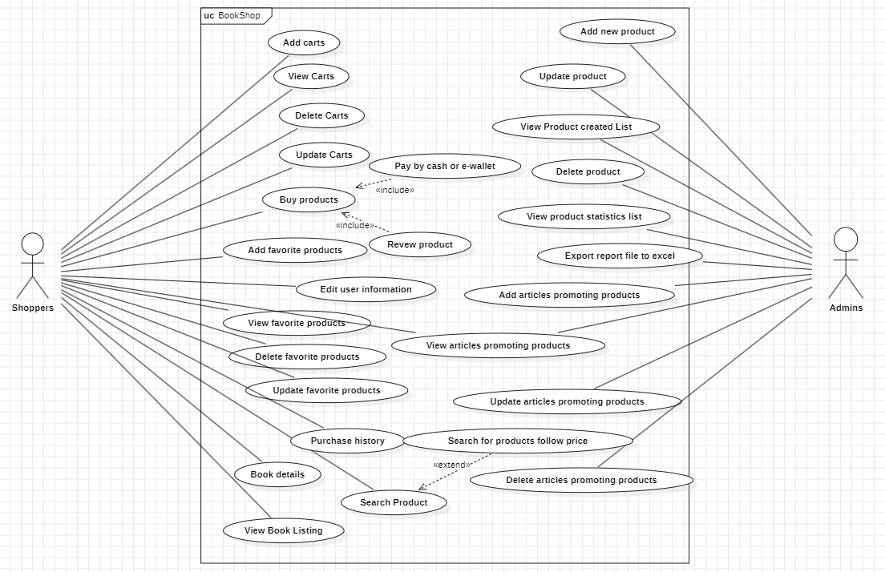

Functional Description

